­­­­

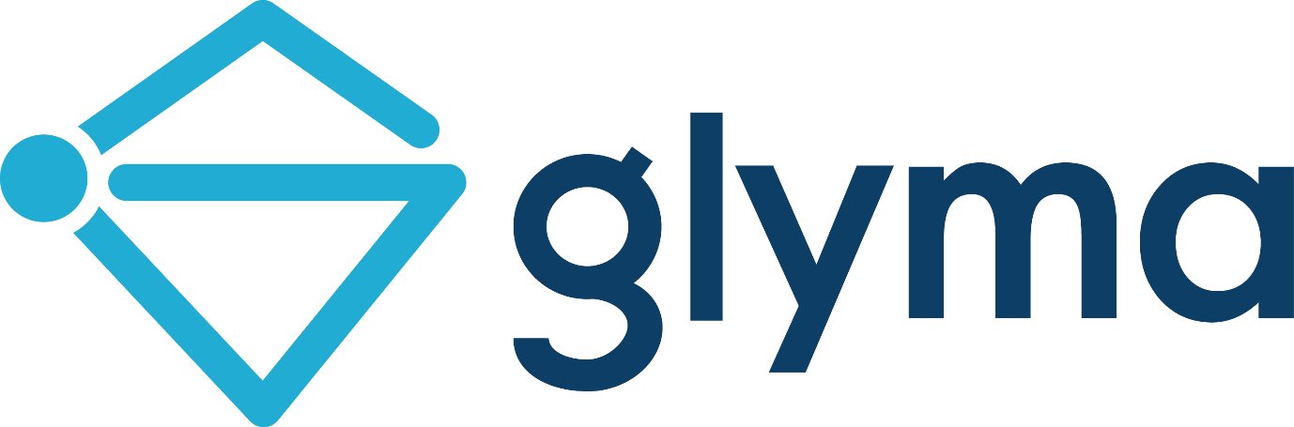

Mapping with Glyma™

http://glyma.co

Contents

Introducing Glyma 5

System Requirements 5

Modes of Glyma 6

Getting Started With Glyma - Explorer Mode 7

Accessing Glyma 7

Glyma Overview 10

Getting to Know Glyma – Explorer Mode 11

Browsing maps 11

Expanding and collapsing a chain of nodes 11

Navigating between maps 12

Map Options Menu 14

Map Zoom Controls 16

Information Options Menu 17

Getting Started with Glyma – Author Mode 20

Creating a Glyma™ Map 20

Editing Functions 29

Monitoring the Status Bar 36

Tagging Functions 37

Managing Glyma Access (For Administrators) 47

SharePoint Security 101 47

How Glyma extends SharePoint permissions 48

Assigning Permissions to Glyma Maps 49

## Introducing Glyma

Glyma is an intuitive and easy to use tool that can help you find, capture and organise information using visual maps.

Glyma augments the capture of information by allowing users to attach relevant information to map nodes. Attachments can be in the forms of videos, slides, documents, supporting text, websites, and more. Information that is captured within Glyma can be easily searched.

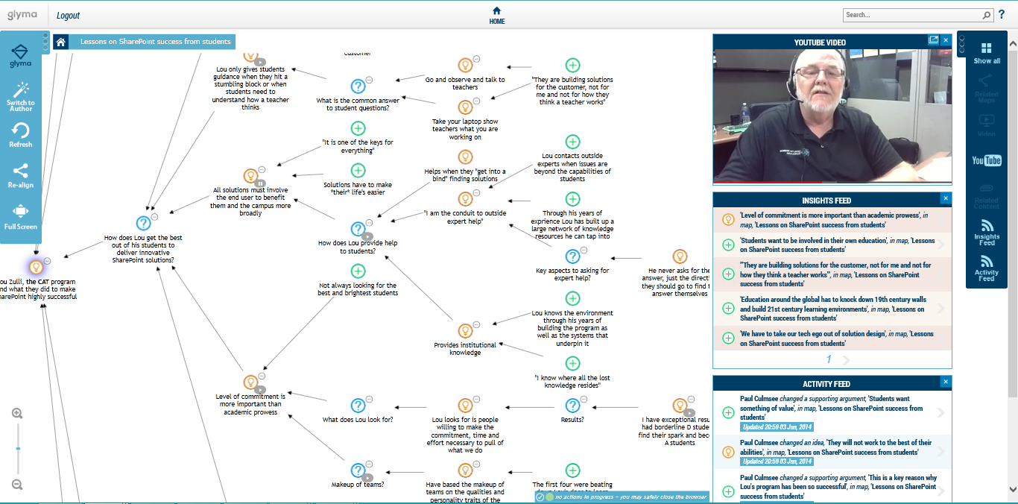

This manual focuses on viewing and authoring using Glyma.

### System Requirements

Software required for running Glyma on your system:

* Install of Silverlight; and
* We recommend you update your browser to the latest version, with IE9 or later if using Internet Explorer.

### Modes of Glyma

Glyma has been developed with two different modes: An Explorer Mode and an Author Mode.

1. Explorer mode: When permissions are set at this level, users can view and browse maps, navigate between maps, and search nodes within a map.
2. Author mode: When permissions are set up at this level, users can still view the maps in Explorer mode, but in addition, change to Author mode where they are able to edit their own maps.

## Getting Started With Glyma - Explorer Mode

This section will take you through what you need to know in order to use Glyma in the Explorer Mode.

### Accessing Glyma

Before you can view maps in Glyma, you need to access the site. Follow the instructions below to access the site.

1. Go to the URL provided
2. The *Sign In* page will appear. Select your logon method

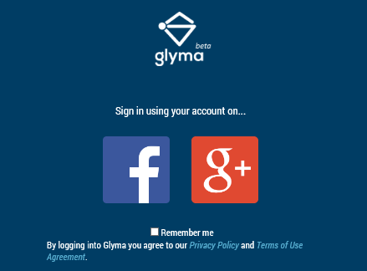

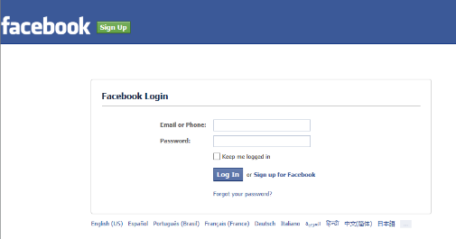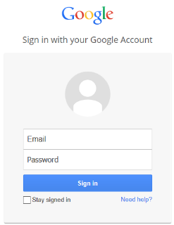Depending on the logon method you choose, you will be taken to the selected logon page.

1. For Windows users: The first time you sign into Glyma, you will be prompted to confirm that Glyma is authorised to use your account:

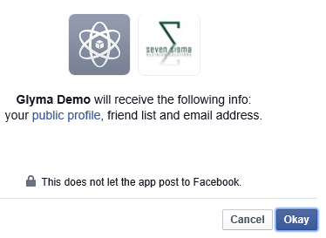 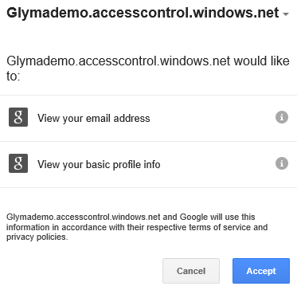

Click *Okay* for Facebook, and *Accept* for Googleto continue.

*Note: Glyma does not collect any additional information, apart from your name and email address. The prompts above are what Facebook and Gmail show by default.*

1. Mac users only: The following security warning will appear. Click *Continue* if using Firefox, and *Send* if using Safari to proceed.

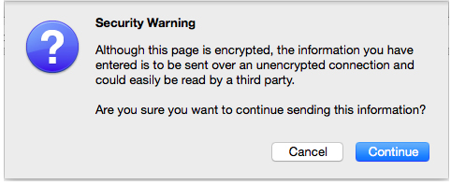 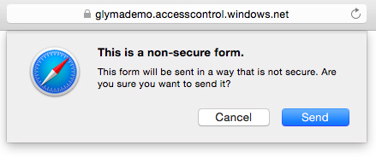

1. Once your log on credentials have been authenticated, Glyma will load with the *Map Selection* box.

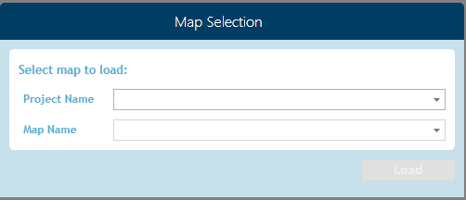

1. Select the Project and Name of the map you want to view from the dropdown list. Click *Load* and the selected map will open.

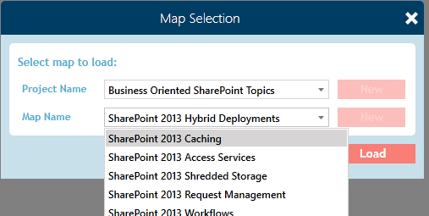

*Note: Glyma has two option panels that are used to operate the software. The lighter coloured Map Options Menu panel on the left and the darker Information Options Menu on the right.*

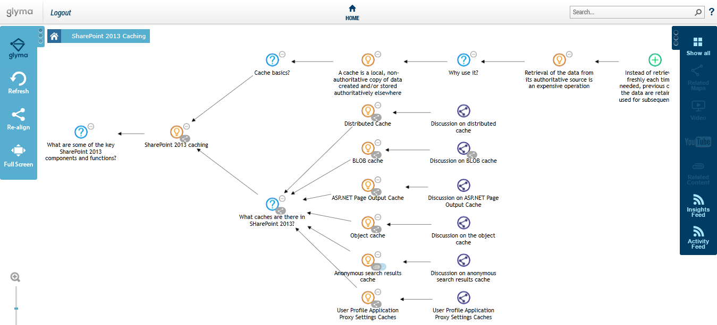

### Glyma Overview

Glyma is divided into seven sections. Below is a representation of Glyma’s layout

2

23

5

1

44 4

3

6

7

6

1. **Map Options Menu:** Allows users to control the appearance of maps in the map canvas
2. **Map Breadcrumb:** Shows which map you are viewing and allows you to navigate between maps
3. **Map canvas:** Area where maps are displayed
4. **Related content panel/window:** Displays additional information about the map content
5. **Information Options menu:** Allows you to choose what content you want to display in the Related Content panel
6. **Map Zoom Controls:** Allows you to zoom and centre maps
7. **Glyma Status Bar:** In author mode, used to monitor connection to Glyma server

### Getting to Know Glyma – Explorer Mode

Glyma offers the following features in the Explorer Mode:

#### **Browsing maps**

There are 2 ways to browse maps in Glyma

1. Left click on any part of your screen and drag the mouse pointer in the direction you want to scroll.
2. Left click anywhere on the workspace and then press the arrow key corresponding to the direction you want. The map will scroll in the direction of the arrow key.

#### **Expanding and collapsing a chain of nodes**

For ease of viewing and map management, a chain of nodes can be collapsed or expanded. A single click of the expand symbol  will show one level of nodes down (Figure 1), and double clicking on it will expand all children levels (Figure 2). Once the expand symbol is clicked, it will be replaced by the collapse symbol . Click on this symbol to collapse the chain to that level.

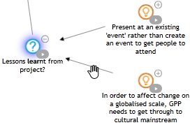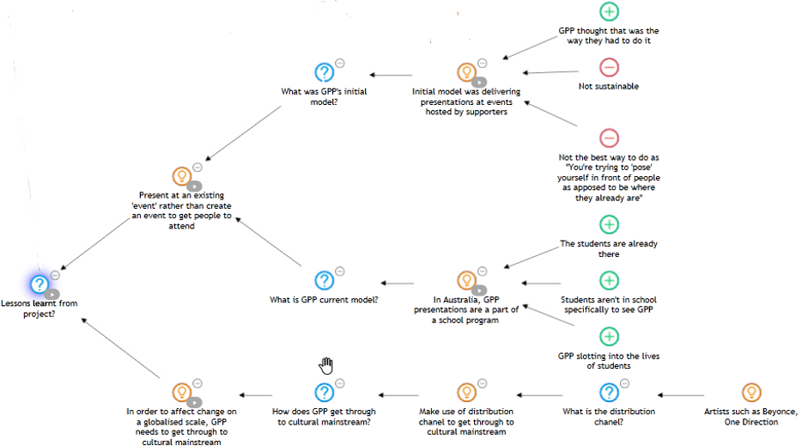

Figure 1

Figure 2

#### **Navigating between maps**

You can navigate between maps via the following methods -

1. Double clicking on a map node, which will open the sub-map.
2. Via the breadcrumb: Each level of the breadcrumb represents a map within a map as shown in the picture below.
3. 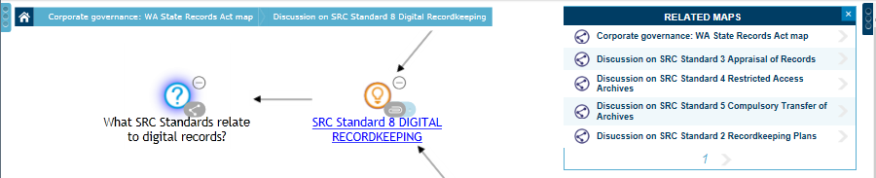Via the Related Maps window of the Information Options Menu: When a node appears in more than one map, it has a small map icon  attached to it. Clicking on this icon or the node to which it is attached, will open the Related Maps window. This will display a list of maps in which the node appears.

Then click on one of the listed maps. The map will open with that node highlighted.

#### Searching nodes within a map

Because Glyma is integrated with SharePoint, it makes use of SharePoint’s search functionality. To search:

1. 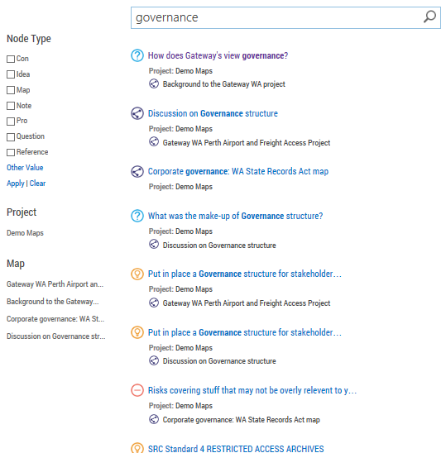Enter your search term in the Search box, then either press the ENTER key on your keyboard or the Search icon in the Search box.

Figure 3

1. Glyma will display a list of nodes that contain the search term (Figure 3).
2. (Optional) Refine your search results using the left refinement panel. By default maps can be refined based on the node type, the map itself or the project containing potentially many maps
3. Hover over the nodes listed and Glyma will display a context box. The context box gives the information related to that node, such as the project name, the map in which it belongs, and the nodes connected to it (Figure 4).

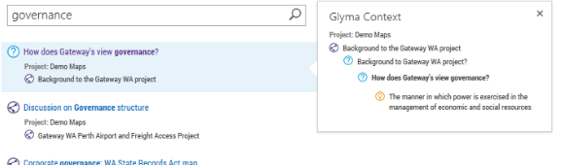

Figure 4: Search showing Glyma™ Context menu

1. Click on the text of the node you want. Glyma will take you inside that map, with the selected node highlighted.

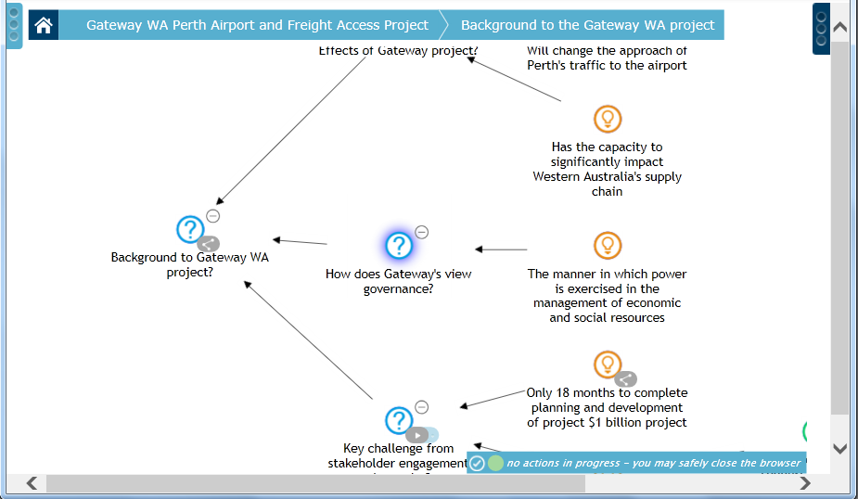

### Map Options Menu

Glyma has a left side menu called the Map Options Menu. To access this menu, click on the left vertical ellipsis symbol, left of the home icon.

This contains the following functional icons:

#### RealignING MAPS

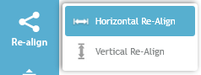This function reorientates your map to either a horizontal alignment (nodes connected from right to left) or a vertical alignment (nodes connected from bottom to top). Click this icon to bring up a submenu with Horizontal Re-align or Vertical Re-align option.

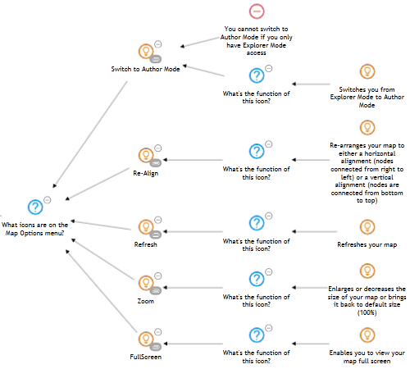 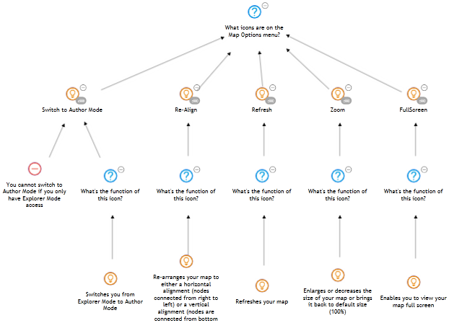

Figure 5: Horizontal re-align (left), and vertical re-align (right)

#### Refresh

Glyma is browser-based so is dependent on your internet connection. Should you have connection issues, click on this icon to refresh your map. Also, if another user has updated the map since you last loaded it, this function will reload your map to the latest version.

#### Full Screen

This function enables you to view your maps on full screen.

Figure 6: From this... …to full screen

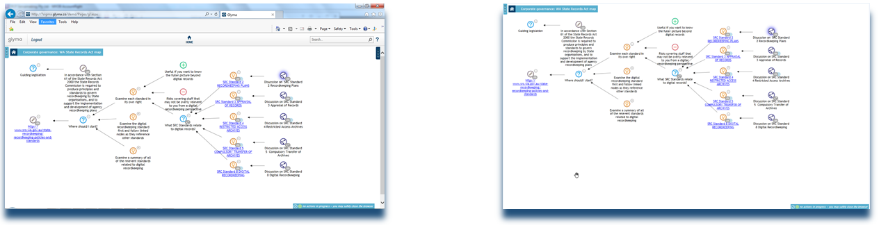

### Map Zoom Controls

Below the Map Options menu on the left is the map zoom controls. This allows you to zoom the map in and out, as well as re-centre the map during zoom operations.

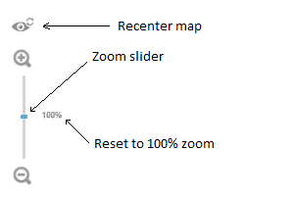

* To zoom out, click the zoom slider and drag it downwards.
* To zoom in, click the zoom slider and drag it upwards.

*Note: To reset to zoom to 100%, click the 100% symbol, rather than use the zoom slider.*

As you zoom in and out of maps, they will often no longer be centred. Clicking the “Re-centre map” icon () will reposition the map correctly. In the example below, the map been zoomed to 120% and the first node is now hidden behind the Map Options menu. On the right, the re-centre map icon has been clicked and the map is now positioned properly.

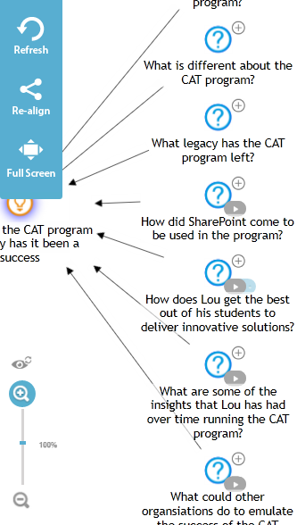 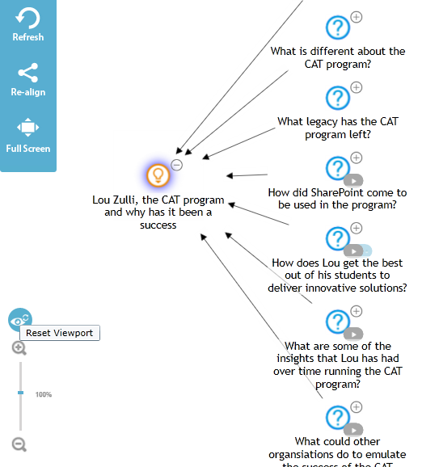

### Information Options Menu

The Information Options Menu, located on the right hand side, is a panel that displays information tagged against a node. These are displayed under various windows/panels: Related Maps, Video, YouTube, Related Content, Insights Feed, and the Activity Feed pane.

#### Related Maps Window

When a node is transcluded (a node that appears in more than one map), it has a small map icon  attached to it. Clicking on this icon or the node it is attached to will open the Related Maps window.

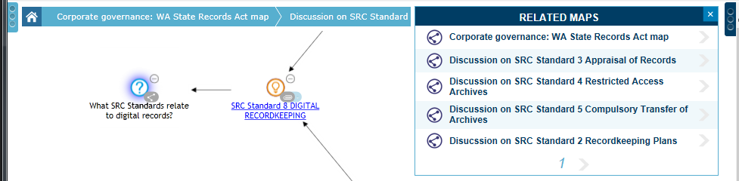

#### Video & Youtube Windows

A node can be tagged against a part of a video. When the node is tagged to a video, it displays a small play icon . Clicking on this play icon will open up the Video window and play the video at which the node is tagged.

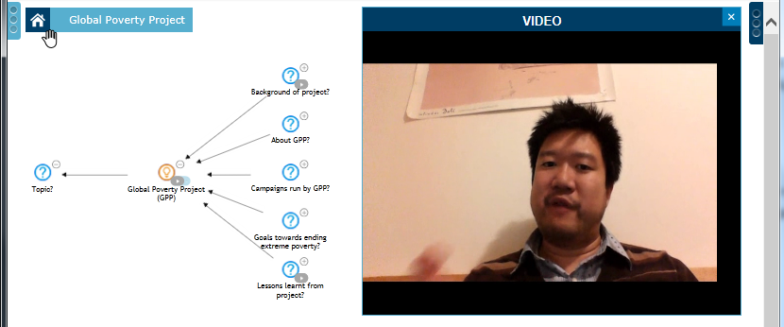

#### Related Content Window

 A Glyma node can have pdf or Word documents, pictures, URL, map location or text tagged against a node. Once tagged, the node will have an attachment icon  attached to it. Clicking the attachment icon will display that tagged information in the Related Content window.

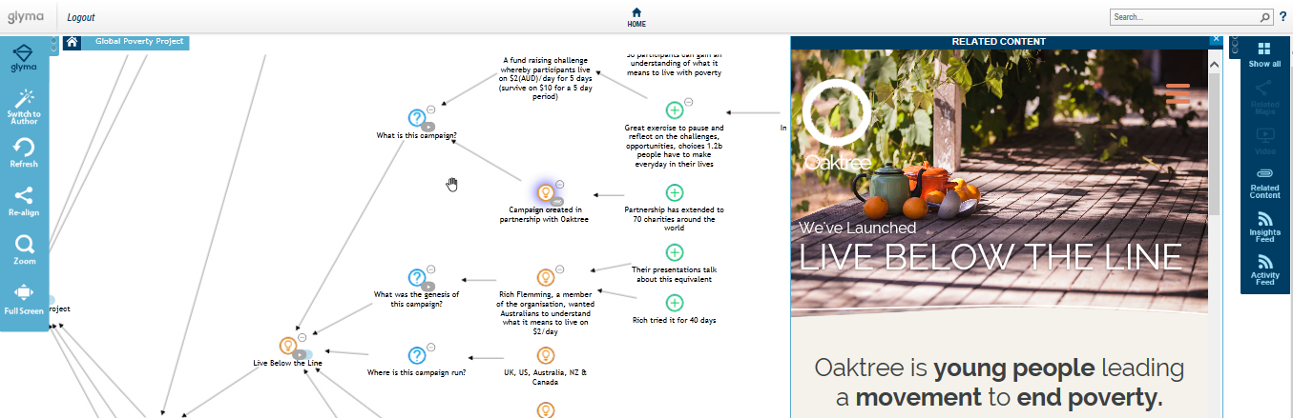

#### Show all

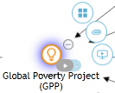 When a node has both video and related content attached to it, it will have a clickable blue shadow behind the tag icon (e.g. play and attachment icons). Click on this blue part and it will bring up the selection of different tags. You can click on the one you want or the *Show all* icon to open up all the panes on the Info Options Menu in which the information has been tagged against.

#### Insights Feed Window

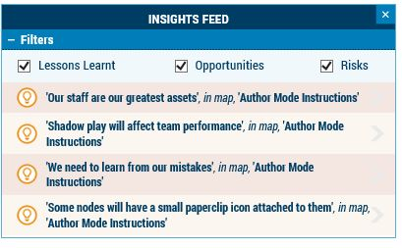This window shows map nodes that have been tagged under certain themes defined by the author. View the nodes in all themes or select the themes you want by checking/unchecking the boxes. By default, Glyma will list about up to 5, and using the arrow icon, you can explore additional nodes tagged.

#### Activity Feed Window

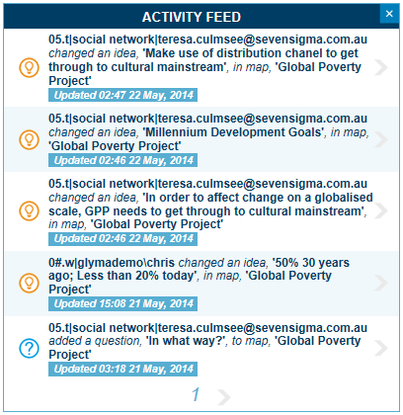The activity feed shows the most recent activity by map authors in the form of newly created or updated nodes. Feeds within this pane will show the Author performing the edtion, if the node as been created or edited, the node label, and the name of the map in which the node was created or edited.

## Getting Started with Glyma – Author Mode

Creating maps with Glyma is a simple process of adding nodes that represent the IBIS elements (Questions, Ideas, Pros and Cons) and linking them together according to the IBIS grammar.

Before you can use Glyma to map, the following are required:

1. Create a new project and
2. Create a new map.

### Creating a Glyma™ Map

#### Creating Your First Glyma™ Project

Once you have logged on, Glyma will load with the *Map Selection* box.

1. Click on the Management Console.

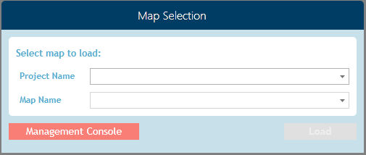

The Management Console will look like below…

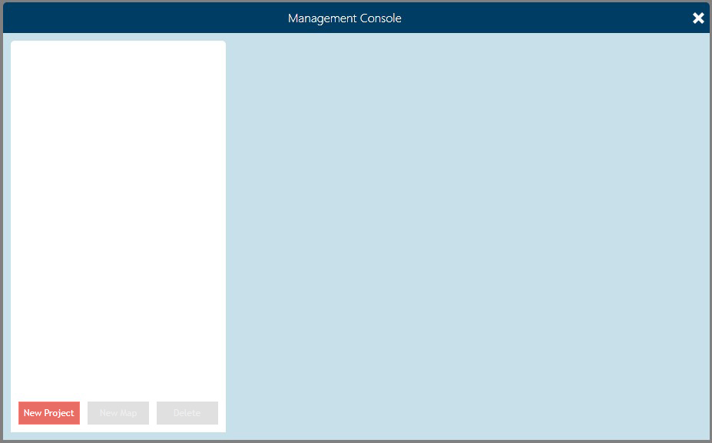

*Note: You need to be granted appropriate permissions by your Glyma administrator to be able to create new maps and projects.*

1. Click on the *New Project* button to load The New Project box. 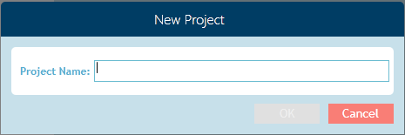
2. Enter a name for this project. Next, click *OK.*

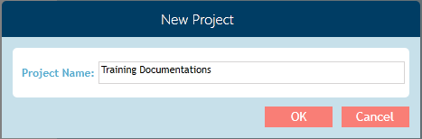

Your newly created project now appears on the navigation pane on the left.

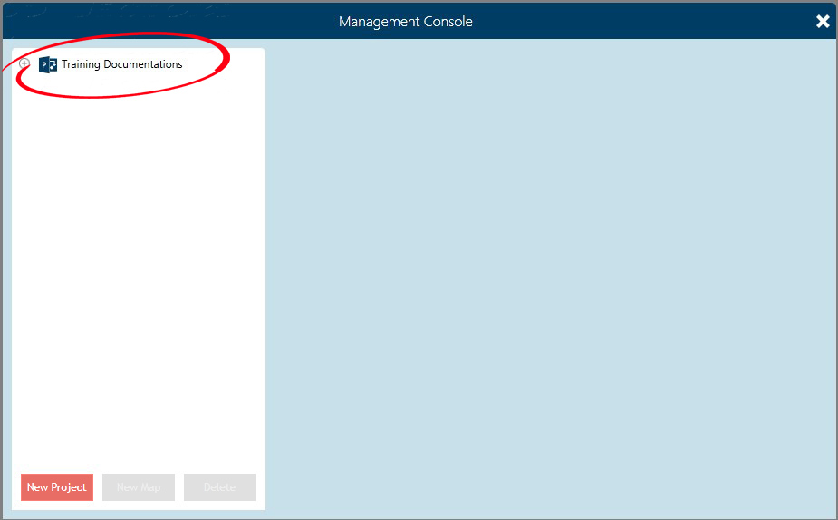

**Renaming the Project title**: To edit, click on the project on left navigation panel to activate the tab labelled *General*. Edit the project name as desire in the Name text field. Click *Apply* once done to commit your changes.

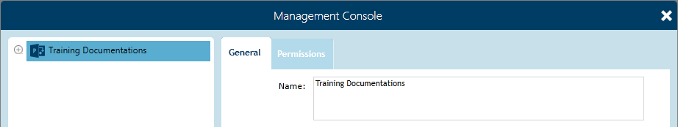

###### Deleting the Project title

1. To delete a project, click on the Project from the list on the left navigation panel.
2. Click on the *Delete* button at the bottom of the left navigation panel. A warning will display. Click *Yes* to confirm.

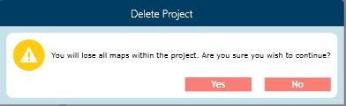

#### Creating Your First Glyma Map Canvas

Once the project has been created, the next step towards your mapping experience is to create a new map under the project you have previously created.

1. Select the Project just created to activate the *New Map* function. Click on the New Map button to bring up the New Map box. Enter a name for this map. Next, click *OK.*

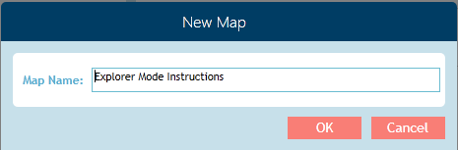

1. Click the expand icon, left of the project name to view the newly created map name.

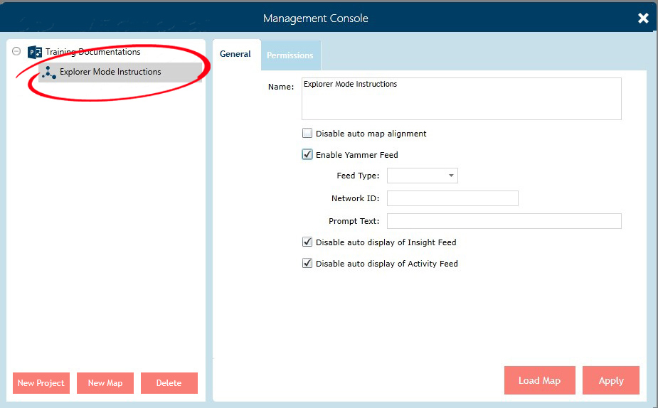

Selecting this map will open up the General tab on the right. This tab allows you to control the behaviour of the map when users open it. It has the following options:

* 1. Disable auto map alignment: This means the map will not re-adjust itself when users expand or collapse node branches.
  2. Enable Yammer Feed: Check to add a Yammer network to your map, allowing for interactive discussions within Glyma.
  3. Disable auto display of Insights Feed: Check to disable the Insights Feed displaying automatically on opening the map.
  4. Disable auto display of Activity Feed: Check to disable the Activity feed displaying automatically on opening the map.

1. Select *Load Map*. Glyma will load a blank map, defaulting to the Explorer Mode.

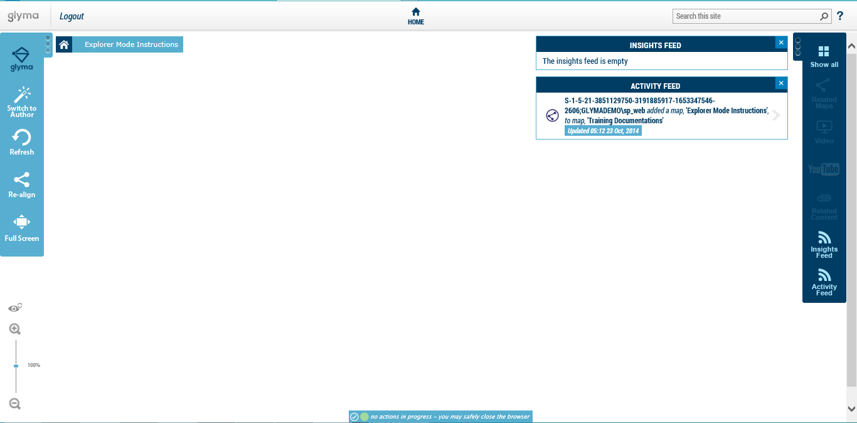

Figure 7: Above - Glyma map canvas loaded with "Disable Auto Display..." options of Insights and Activities Feeds unchecked. Below – Glyma map canvas loaded with “Disable Auto Display…” options of Insights and Activities Feeds checked.

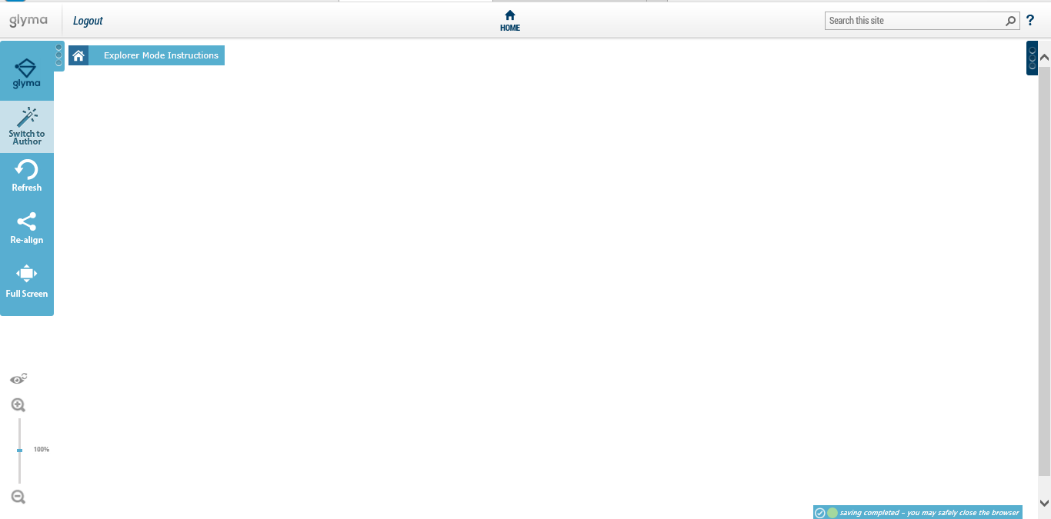

1. Click on the *Switch to Author* icon on the Map Options Menu on the left side of the screen to go into the Author mode.

#### Opening a Previously Created Map

To open a previously created map:

1. Via the Map Selection box:
   1. Select your project to which the map belongs to from the Project Name dropdown list; then
   2. Select the required map from the Map Name dropdown list;
   3. Click *Load Map*
2. Via the Management Console:
   1. Within the Management Console, click on the expand icon left of the project name to show the list of maps within that project.
   2. Select the map you want from the list, then click *Load Map*.

#### Creating Nodes

The basic node creation functions of Glyma are based on keyboard keys. To map with Glyma, you can create nodes via the following shortcut keys:

|  |  |  |
| --- | --- | --- |
| **NODE** | **NODE TYPE** | **SHORTCUT KEYS** |
|  | Question | Q |
|  | Idea/Answer | I |
|  | Pro (Argument) | P |
|  | Con (Argument) | C |
|  | Map | M |
|  | Decision | D |

*Note: There are two ways to create nodes in Glyma. Regardless of which method used, you must click on the Switch to Author icon on the Map Options Menu to go into Author Mode.*

Method 1:

To create a node in Glyma…

1. Click onto the workspace (the white area of the screen).
2. Press the above keyboard letters to create the required nodes.
3. Type your data into the label field below the node icon.

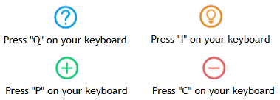

Method 2:

1. You can also create nodes by right clicking on the white space on your canvas to bring up the menu below.

*(For Mac users: Control+Click on the white space)*

1. Select *Create New…* then select the node you want.

*Note: This method is not recommended for more experienced users as it is slower than using the keyboard shortcuts.*

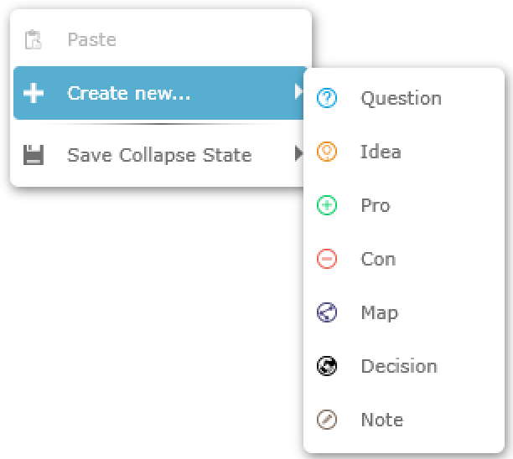

#### Linking nodes

Nodes by themselves don’t provide context as the relationships between them are not specified, so they need to be connected. Nodes are connected to each other by arrows that point from the child node to the parent node, i.e. right to left, or bottom to top. The reason for this is that the idea behind Glyma’s notation is that all discussions must lead back to the root (original) question.

To link your nodes (Example – linking Idea node to Question node):

1. Place your cursor over the Idea icon (not the text part),
2. While right clicking on the Idea icon, drag your cursor to the Question icon. You should see an arrow following your cursor as you drag. Once the cursor reaches the Question icon, release the keys.

*(For Mac users: Control+Click and drag).*

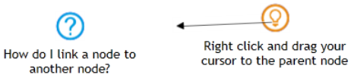

Creating new linked nodes

To create a node and have it automatically linked to a previous (parent) node, select the parent node, hold down the Shift key and press the shortcut key for the node you want to create. The new node will be automatically connected to the selected (its parent) node.

#### Selecting a node

Single node selection

While holding down the left mouse button, click on the required node. The selected node will be highlighted.

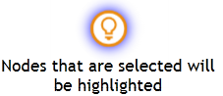

Multi-node selection

There are three ways to select multiple nodes…

1. Method 1: Hold down the Shift key while clicking on each required nodes.
2. Method 2: To select a chain of nodes – while holding down the Control key, left click on the parent node of the chain. The parent node and all its children will be selected. *(Note: This method is not compatible with Macs).*
3. Method 3: While holding down the left mouse button, draw a box around the required nodes. The nodes within the box will be highlighted.

#### Deselecting nodes

Deselecting all nodes

To deselect a single highlighted node, left click on the white space of your map.

Deselecting node(s) from a group of selected nodes

If you have multiple nodes that have been selected and want to deselect one or two from the selection, while the nodes are selected, hold down the Shift key and left click on the nodes you want deselected. These will now be un-highlighted.

#### Importing Compendium Maps

Compendium is a software tool that uses the same mapping notation that Glyma does. Unlike Glyma, it does not need an internet connection and is therefore useful in some scenarios. In a situation whereby internet connection is not available, users can create a map in Compendium and then collaborate on it further using Glyma. Accordingly, Glyma is able to import maps from Compendium.

*Note: This function is not available on Macs.*

1. Locate the zipped or xml Compendium export file to be imported into Glyma
2. Drag and drop this zipped file into Glyma

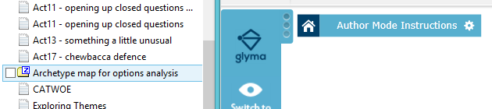

1. Your Compendium map will be imported and processed as a Glyma map. Be patient here as larger maps can take some time. When the import has finished, double click on the map node to open the map. 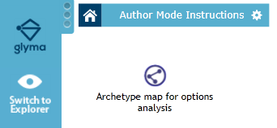

### Editing Functions

#### Editing Node text Box

The quickest way to edit the node text is to left click on the node’s text. The textbox will appear. Start editing your description. To commit your changes, press enter or left click outside the textbox.

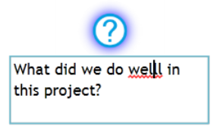

You can also edit the node text via the node context menu.

1. Right click on the node to bring up the node context menu. *(Mac: Control + Click on the node).*
2. Select *Properties*
3. In the Name text field, under the General tab, edit your text then click *Save* to commit your changes.

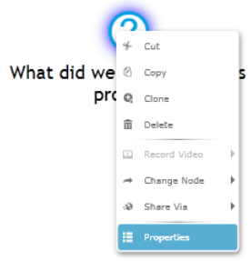 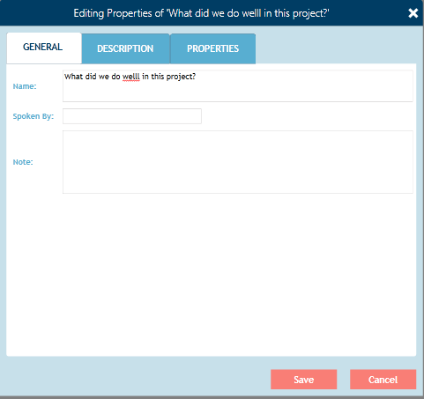

#### Deleting nodes or links

You can delete nodes in two ways:

1. Click on the node or link, then press the Delete key on the keyboard *(Mac: This function is not available on Macs);* or
2. Right click on the node to be deleted, and select Delete. *(Mac: Control + click on the node to be deleted, then select Delete).*

#### Changing the type of an existing node

Sometimes you create one type of node when you actually want another. Rather than deleting the node along with its description and creating a new one, you can change the node type.

To change the node type:

1. Right-click on the node to bring up the node context menu *(Mac: Control click on the node).*
2. Select *Change Node…* from the menu,
3. Scroll across to the submenu and select the correct node type you need.

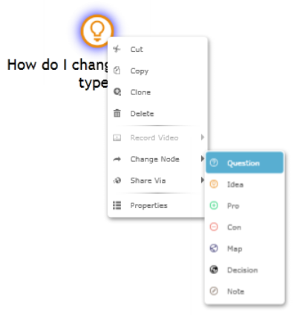

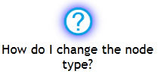

#### Copying & Pasting Nodes

Glyma allows you to copy nodes from one map to another map. Behind the scene, every Glyma node has a unique ID. Each ID can only exist on one map, thus nodes can be copied to another map but not to the same map. Copied nodes, even though existing in more than one map, are the same nodes. If you change the node type, text description or other properties of the node in one map, the changes will also occur in the other maps.

There are 2 ways to copy nodes to another map.

Method 1:

1. Select the node(s) to be copied
2. Press Control + C on your keyboard to copy to the clipboard
3. Double click on the map node to go inside that map
4. Press Control + V to paste your selected node(s) inside that map

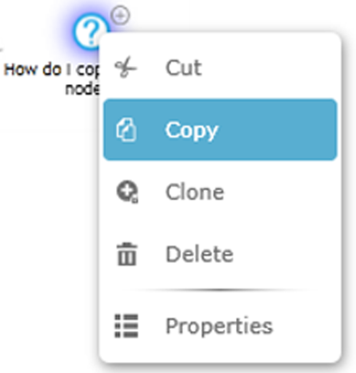Method 2:

1. To copy, right click on the node(s) you want to copy to bring up the node menu. Select *Copy.*
2. 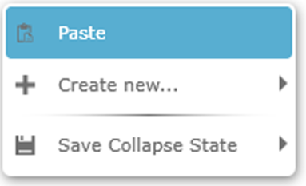Go to the map you want the node(s) copied to, right click on the white space and select *Paste.*

#### Cloning nodes

Unlike a copied node, a cloned node has a different ID to its original node so can exist in the same map. Because of its own ID, changing the original node will not change the clone, and vice versa.

To clone a node…

1. Select the node(s) to be cloned.
2. Right click on the selected node(s) to display the node context menu. *(Mac: Control click on the node).* Select Clone. The cloned node(s) will appear near the original node(s).

­ 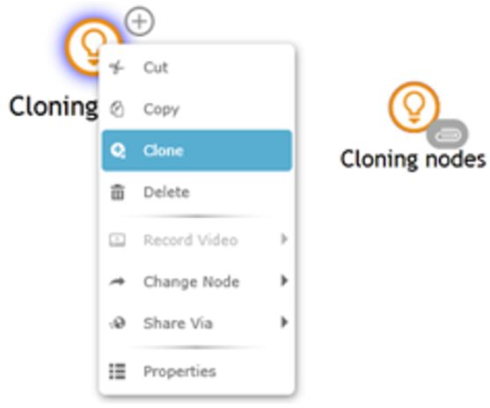

#### Moving nodes

To move a single node around the canvas:

1. Select the node to be moved.
2. Drag the node to the desired space.

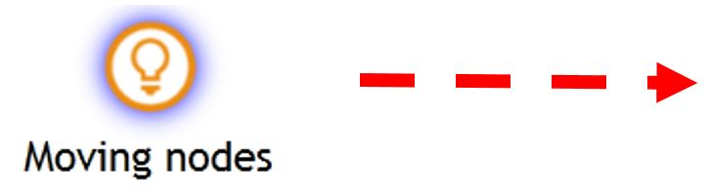

To move multiple nodes around the canvas:

1. Select the nodes to be moved
2. With the cursor over one of the selected nodes, drag them to the desired space

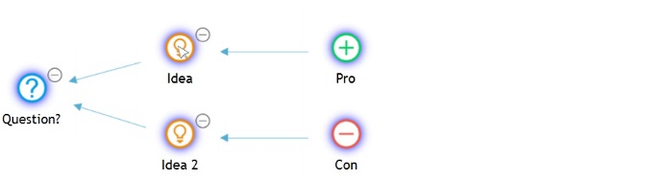

#### Realigning Map

This function re-arranges your map to either a horizontal alignment (nodes connected from right to left) or a vertical alignment (nodes connected from bottom to top). Click this icon to bring up a submenu with Horizontal Re-align or Vertical Re-align option..

 

Shortcut keys for horizontal alignment: Control+Shift+R

Shortcut keys for vertical alignment: Control+Shift+V

#### TIDYING MAPS

Your maps can be quite untidy during the creation process. To neatly rearrange your nodes:

For horizontal maps, press the ControlL+Shift+R keys on your keyboard, or the Re-Align icon 🡪Horizontal Re-align.

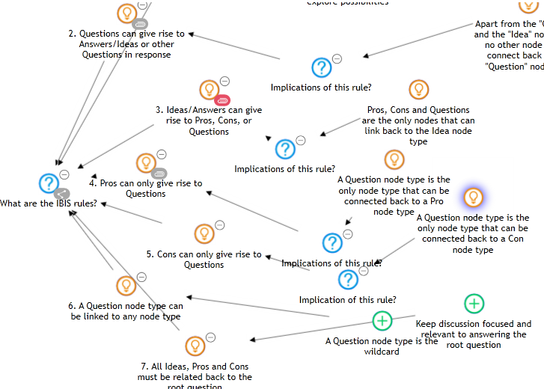 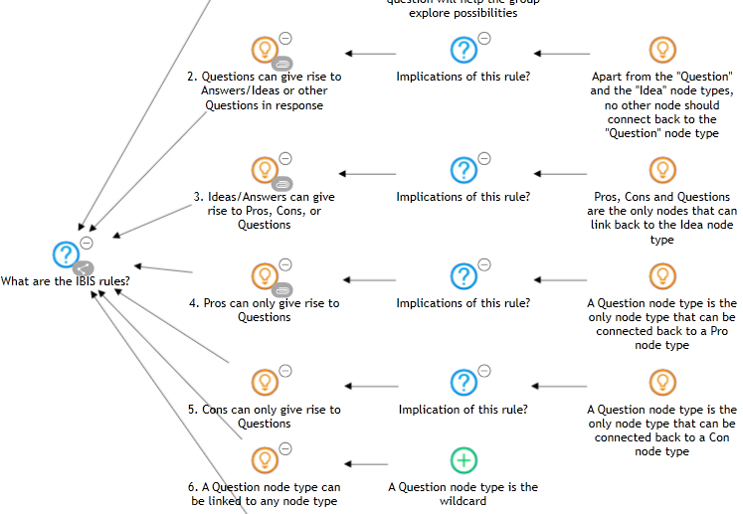

For vertical maps, press the Control+Shift+V keys on your keyboard, or the Re-Align icon 🡪 Vertical Re-align.

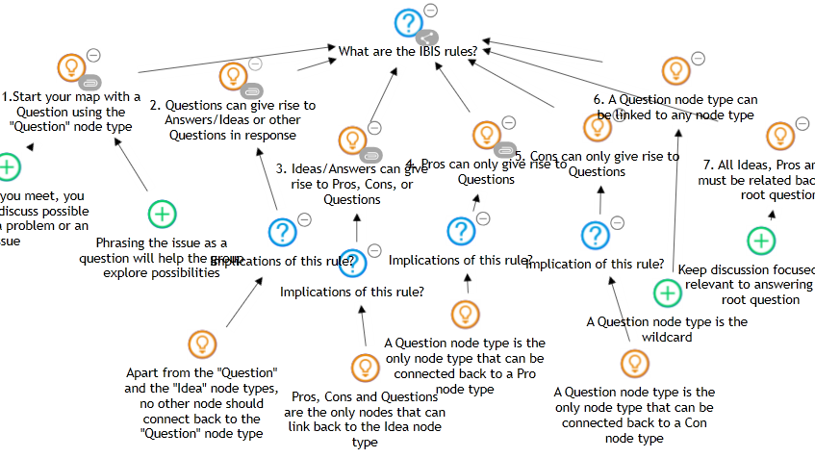 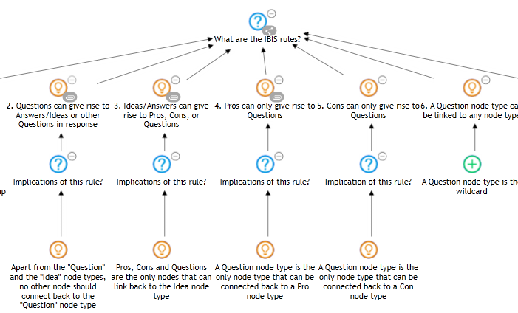

#### Exporting Glyma Maps To JPG

Currently, users can export maps to jpgs. To do this, hold down Control+ALT+S, then save the jpg to your chosen location.

*(For Mac users, hold down Control+Option+S).*

#### Saving Map State

When a big map is loaded on screen in its full expanded state, it may be too much for viewers to take in, especially for those who are new to Glyma. Where do they begin?

Also, for map authors who have been working on a big map, it can be time consuming for them to scroll and find the section where they have left off.

To make the viewing experience easier, and the authoring experience more productive, Glyma allows authors to save the map state. That is, you can collapse the map to how you want it to be presented, save that state, and when it is loaded next time, it will be at that saved state. These map states can be saved to look the same in each mode, or Explorer different to the Author Mode.



Figure 8: From this (8A. above)...to this (8B. below)

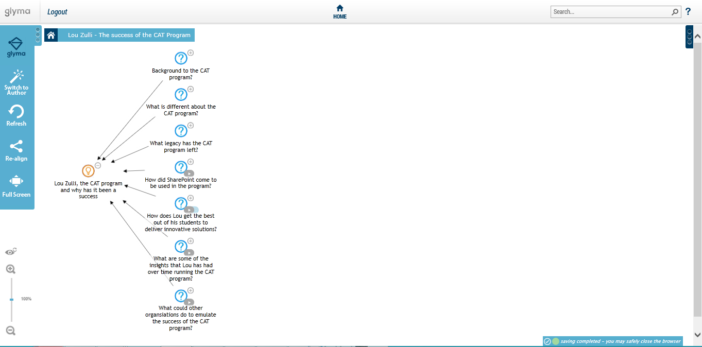

To save the collapse state:

1. Collapse your map to the desired level by clicking on the collapse icon  next to the nodes.
2. Right click on the white area to bring up the menu below, and select *Save Collapsed State,* then select either *Reader,* or *Author. (For Mac users: Hold down Control and click on the white area of the canvas).*

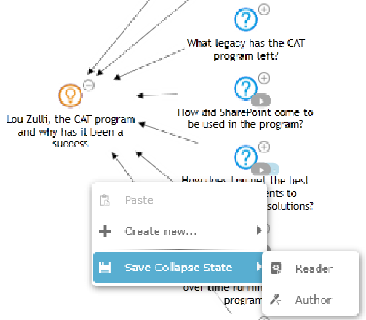

* 1. Reader option: When the map is next loaded in the Explorer mode, it will be loaded at this saved collapsed state.
  2. Author option: When the map is next loaded in the Author mode, it will be loaded at this saved collapsed state.

### Monitoring the Status Bar

In Author mode, the Glyma status bar is used to monitor connection to the Glyma server. Each time you do something in Glyma (e.g. creating a node, linking nodes, deleting, moving, etc), it is called an action. Each action is automatically saved to the server. The status bar shows how many actions are still being saved (For example, 3 actions being saved in the picture below).



The speed at which Glyma saves your actions depends on the speed of your connection. We recommend you keep an eye on the status bar, and should you see the number of actions to be saved build up, stop using Glyma and wait for it to save all actions before continuing. If the number of actions to be saved continue to build up, with no signs of decreasing, your work may not be saved.

Should this happen, right click on the red circle to bring up “*Forcefully Save Transactions”* message. Click on this to force the save actions. The number within in the red circle should start counting down.



In the event that the actions do not appear to be saving at all. That is no sign of the number decreasing, you may need to refresh the map by clicking on the Refresh icon on the left Map Options menu. If this fails, you will need to refresh your browser by clicking on the refresh icon, right of the address bar.



Refreshing your browser will take you away from the Glyma site; you will need to log in again. This means that the unsaved actions will be lost. If it comes to a browser refresh, we recommend take a screenshot of the map, and remap what has not been saved after the browser refresh.

### Tagging Functions

Glyma nodes have been developed to have extra information tagged or bookmarked against them. Once tagged, the information is then displayed in the Info Options Menu on the right under the associated windows – Related Content, Videos, YouTube and Insights Feed. This ability to attach rich media such as videos, documents and websites to the content of their maps enables users to capture and preserve rich context.

#### Tagging a Node as an Insight

Often in your maps, there will be information captured that needs to be brought out to the forefront, such as opportunities, lessons learnt, and risks. Glyma has been developed for users to call these out so they can be brought to our attention at a glance.

There are two major steps in tagging nodes as insights:

1. Create tag names
2. Tag the insights

Step 1: Create Tag Names

To create tag names:

1. Switch to Author Mode
2. Open the root map (top level map). Click on the settings cog icon to the right of the breadcrumb to open the Properties dialogue box

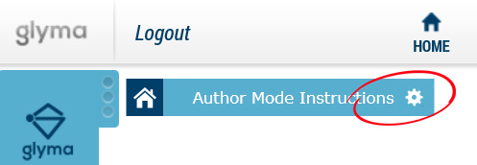

1. Select the *Properties* tab. Enter the details in the Properties box as follow, using Opportunities as an example tag:

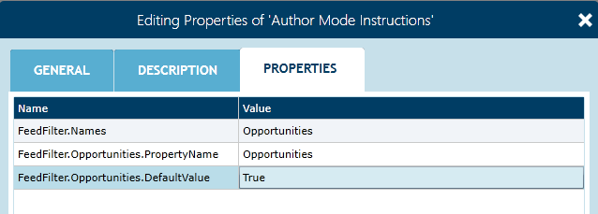

To create multiple tags, enter as below

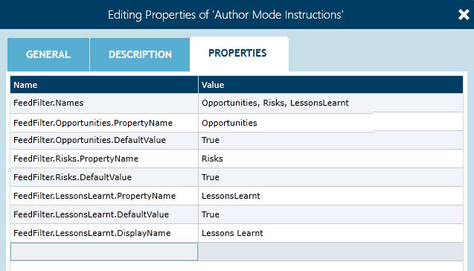

*Note: For tags with more than one word, do not enter spaces between words in the FeedFilter fields. Add the DisplayName field and in the Value field, enter the name with spaces as you want it displayed in the Insight Feeds window. With single word tags, the DisplayName field is not required, as Glyma will display the single name tag automatically.*

*If you make changes to this properties box, click the home icon to reload your map.*

1. Press *ENTER* to finish, then *Save* to commit. If you do not press *ENTER*, you will need to click *Save* twice.

Step 2: Tag Nodes as Insights

To tag a node as an insight:

1. 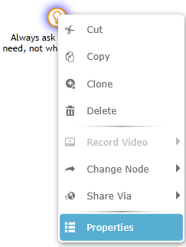Right click on the node to bring up its context menu. Select *Properties.*
2. Glyma will display the Editing Properties window of that node. In the text field under *Name*, type in the tag name created in Step 1, and under the *Value* field, type in True. Press Enter on your keyboard, and click *Save* at the bottom of the properties box.

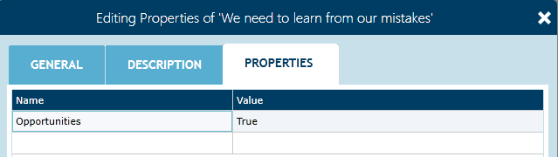

1. Display the Insights Feed window by clicking on the Insights Feed icon on the Information Options menu on the right. The tagged insight(s) will now appear in the Insights Feed window. You can filter the type of insights to be displayed by checking/unchecking the check boxes.

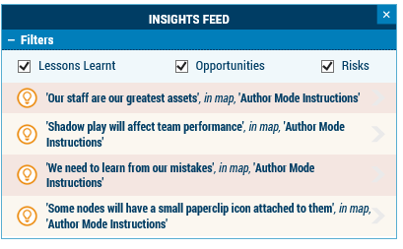

If you have the Insights Feed window open while tagging insights, the newly tagged insights will not automatically appear in the window. To update the window, uncheck and check the tag name.

#### Tagging websites to a Node

Websites, along with their documents and pictures can be tagged against a node using the Embed Web Page function. Once tagged, the information is displayed within the Related Content window.

To attach a website to a node:

1. Right click on the node to bring up its context menu. Select *Properties*.
2. 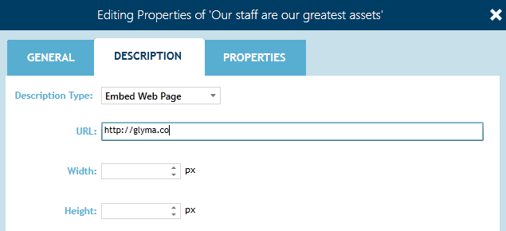Click on the *Description* tab and then choose *Embed Web Page* in the dropdown menu of the *Description Type* field
3. Enter the URL – For web pages, documents, pictures, etc

You can add in the Width and Height of the display window, otherwise Glyma will display the attached defaulting to 400x400px

1. Click *Save*.
2. Your node will now have a small attachment icon on the bottom right. Click on this icon to display the web site in the Related Content window.

*Note: If you want to link to a specific page on the document: [URL]#page=[page number]. For example –* [*http://www.sro.wa.gov.au/sites/default/files/src-standard4.pdf#page=6*](http://www.sro.wa.gov.au/sites/default/files/src-standard4.pdf#page=6)

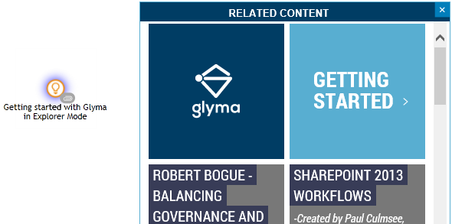 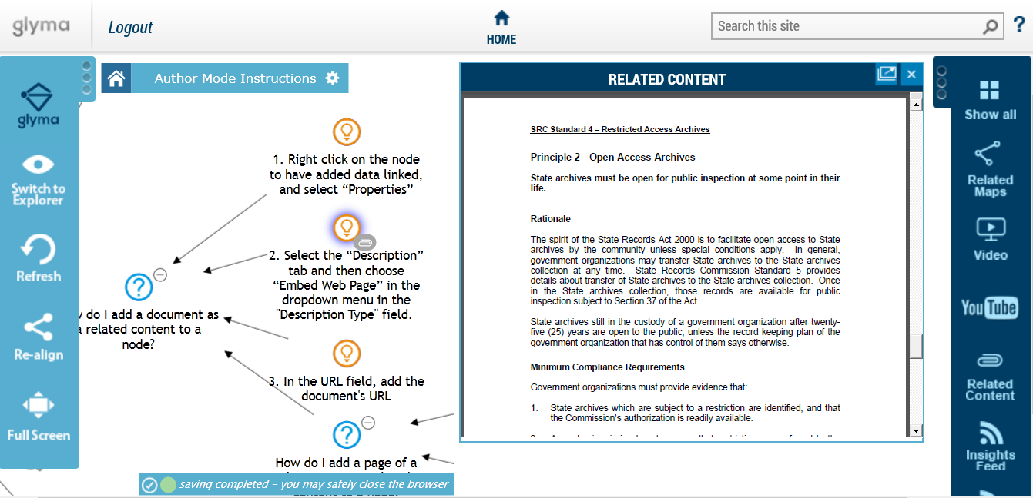

Figure 9: Related Content window displaying an attached document from a website (left), and Related Content window displaying an attached web site (right)

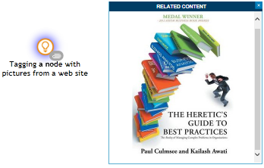

Figure 10: Related Content window displaying an attached picture from a web page

#### Tagging Text, Hyperlinks, Pictures to a Node

To attach text to a node:

1. Right click on the node to bring up its context menu. Select *Properties*.
2. Click on the *Description* tab and then choose *Text* in the dropdown menu of the *Description Type* field.
3. 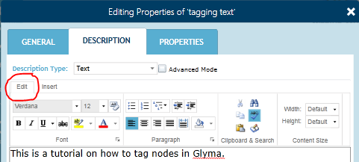Click the *Edit* tab, if not already selected. Type in your text.
4. Click *Save*.
5. Your node will now have a small attachment icon on the bottom right. Click on this icon to display the related text in the Related Content window.

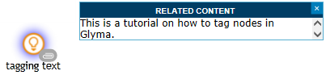

Figure 11: Related Content window displaying related text tagged against a node

*Note: Related text can be tagged alone, or in conjunction with other related information, such as tables, pictures, hyperlinks, date & time, codes and symbols using the Insert function.*

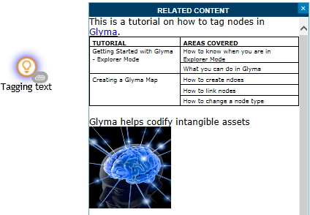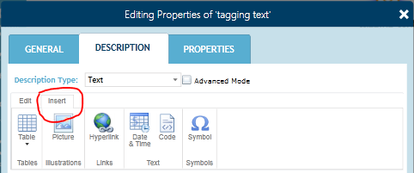

Figure 12: Nodal property box displaying the Insert function (left). Related Content window displaying a combination of text, hyperlink, table and picture (right).

#### Tagging Documents to a Node

Glyma has the ability to display documents of different types from various sources. This section outlines how to attach documents to a node so they can be displayed within the Information Options menu.

Note: Depending on your browser configuration, the type of document you are working with and where that document is stored, the steps and results will vary. For example:

* If Adobe Acrobat reader is installed, you are able to display PDFs in the Information Options panel. If it is not installed, you may be prompted to save the PDF instead.
* If you wish to display a Word, Excel or PowerPoint document, you will need to store it in a location that allows the document to be embedded in other web pages. Many online document storage systems allow this, such as OneDrive, SharePoint with Office Web Applications installed. If you are not using one of these approaches, then use the Google Docs method described at the end of this article.

#### Tagging OneDrive Files to a Node

1. Sign in to your Microsoft OneDrive site, and open the document or picture you want tagged against your node.
2. 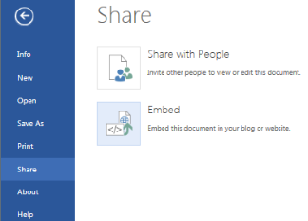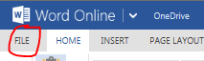Click on the *File* menu and select *Share > Embed*
3. The Embed window will open to display a preview of the document (or picture) and the embed code for the document which has been generated by OneDrive.
4. Go to Glyma. Right click on the node to which you want the file attached to bring up its contextual menu. Select *Properties*.
5. Click on the *Description* tab and then choose *Text* in the dropdown menu of the *Description Type* field.
6. Check the *Advanced Mode*
7. Copy and paste this code into Glyma’s text box. (Mac: Use Command+C to copy, and Command+V to paste). Click *Save*.
8. 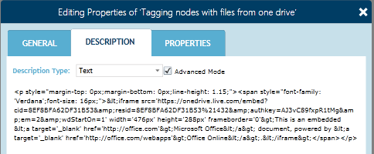Click on the attachment icon on the node to display the tagged file from OneDrive in the Related Content window.

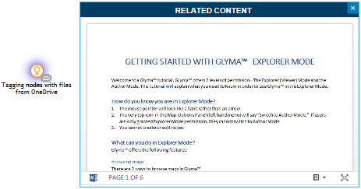

Figure 13: Related Content displaying a document from OneDrive tagged against a node

#### Tagging SlideShare Videos to a Node

1. Locate the slides you want from SlideShare
2. Click on the *Embed this presentation* function located at the bottom of the slide



1. Copy the embed code generated by the site. For Windows users, use Control+C to copy, and for Mac users, use Command+C.

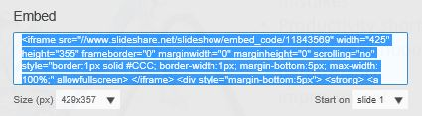

1. Go to Glyma. Right click on the node you want to have the SlideShare video tagged against to bring up its contextual menu. Select *Properties*.
2. Click on the *Description* tab and then choose *Text* in the dropdown menu of the *Description Type* field.
3. Check the *Advanced Mode*
4. Paste the embed code into Glyma’s text box. Click *Save*.
5. Click the node’s attachment icon to display the tagged video in the Related Content window.

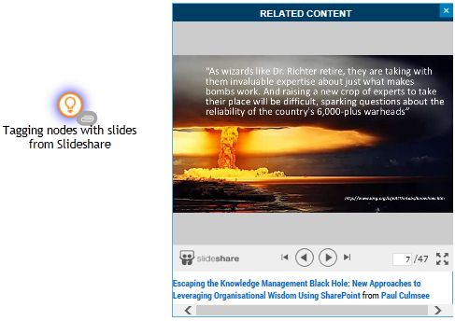

#### Attaching YouTube Videos

1. Locate the YouTube video you want. Copy its URL.
2. In Glyma, click on the YouTube icon on the Info Options Menu on the right to display the YouTube window. (To display this side menu, if it is hidden, click on the vertical ellipsis symbol on the right).
3. Paste the URL into the address bar of the window, then click *Go.*

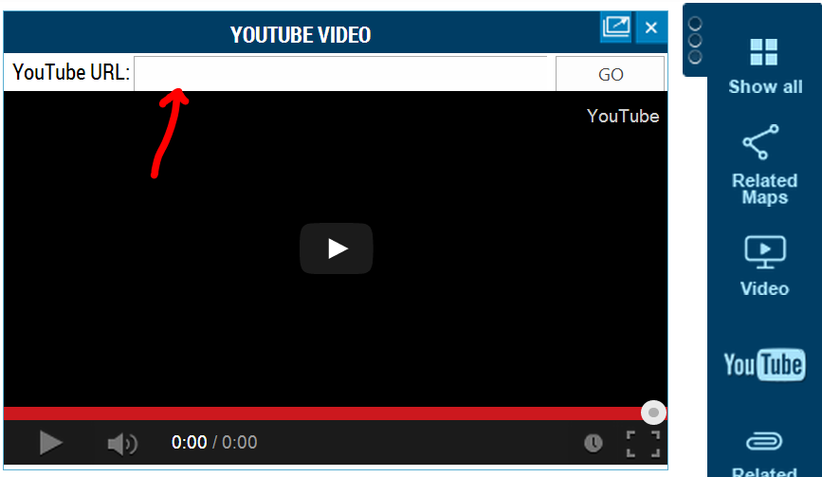

Paste the YouTube video URL into here

1. 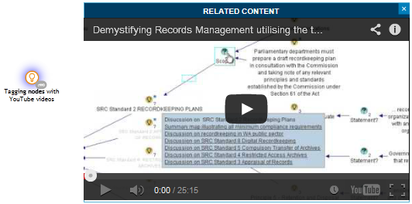Glyma will load that video.

#### Tagging Start and End Positions of Videos to a Node

One great Glyma feature is its ability to tag (bookmark) a node against the exact location of the video which relates to the node itself. We recommend you tag the complete video to the first node of the map.

To tag video positions to nodes:

1. Load your video into Glyma using one of the video attachment methods outlined previously.
2. Play the video.
3. 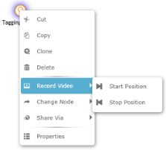At the position you want the node to be bookmarked against the video, pause the video. (You can also bookmark the video position while it is playing).
4. Right click on the node to be bookmarked to bring up the node menu. Select *Record Video > Start Position*
5. The node will now have a play icon attached to it.
6. To record the end position of the video, select *Record Video > Stop Position.*
7. Click on this play icon and the video will play.
8. To fine tune to the exact video position, click on the Refresh icon on the Map Options Menu on the left.
9. Right click on the node that has just been bookmarked against the video to bring up the node context menu. Select *Properties* to open the detailed label window.

This window allows you to add and adjust data. For example, in the Spoken By field, you can add the name of the speaker. To fine tune the tagging of the node to the video, Click on the Properties tab. Double click on the *Video.StartPosition* and *Video.EndPosition* value fields and manually adjust the timing to the exact part of the video you want the node to be tagged.

## Managing Glyma Access (For Administrators)

Glyma administrators can set permissions on Glyma projects and maps to ensure appropriate access to view or modify maps. This section outlines how to perform security management.

As Glyma integrates with Microsoft SharePoint, it leverages the SharePoint security architecture. Therefore, some background knowledge in SharePoint security and permissions is helpful. Before we get into applying permissions to Glyma maps, we will briefly examine the fundamentals of SharePoint security.

### SharePoint Security 101

SharePoint permissions are highly granular, consisting of permissions, permission levels, groups and users.

* A SharePoint permission level (eg Full Control, Contribute or Read) consists of a number of individual permissions.
* Groups contain users
* Permissions on SharePoint objects (like a site, document library or a folder) are set by assigning a group and permission level to the object.

Conceptually, this is shown below. In this example, permissions are applied to a SharePoint site.

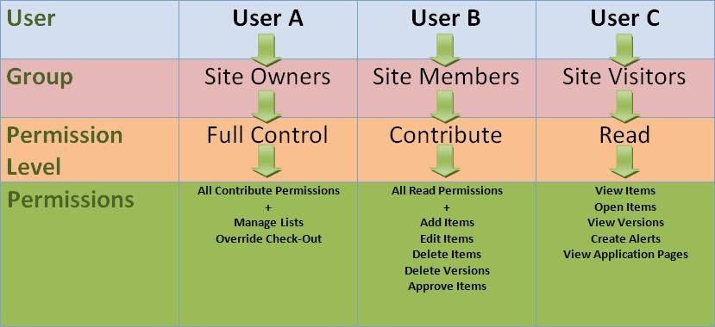

For many deployments, the same groups used to govern permissions to SharePoint would also be used for access to Glyma maps. Glyma has accordingly been designed with this assumption. After all, to access Glyma you need access to SharePoint.

### How Glyma extends SharePoint permissions

Glyma extends on the built-in SharePoint permission levels:

* Glyma Project Manager
* Glyma Map Manager
* Glyma Map Author
* Glyma Map Reader

These can be seen with the built-in SharePoint permission levels below (assuming SharePoint 2013):

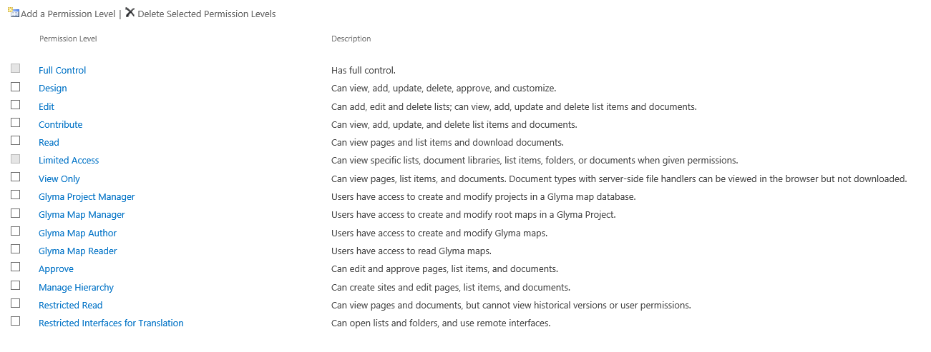

Glyma permission levels govern what users can do when using Glyma. The permission levels are cumulative.

* **Glyma Map Reader**: Allows you to view maps, but not modify them. This is typically assigned to the Visitors group for the SharePoint site.
* **The Glyma Map Author**: Allows users to view and author maps. They can also modify map containers, but not create or delete map containers.
* **The Glyma Map Manager:** Allows users to view and author maps, and create, rename and delete map containers within a project. They cannot create or modify projects themselves.
* **The Glyma Project Manager:** Allows users to view and author maps, create, rename and delete Glyma map containers and projects. This permission level is typically assigned to the owners group for the SharePoint site.

*Note: There is another special built-in SharePoint group called* ***Site Collection Administrators****. This is a very important group in terms of Glyma, because only members of this group are able to set permissions on Glyma projects and maps. This is further elaborated in the next section.*

### Assigning Permissions to Glyma Maps

Assigning permissions to Glyma maps follows three basic steps:

1. Create the groups you need in SharePoint site permissions (if required)
2. Assign the appropriate Glyma permission level to the groups in SharePoint
3. In Glyma management console, apply specific permissions to Glyma projects or maps (if required)

Each step is examined in turn:

#### Create the groups you need in SharePoint site permissions

If you need to create new SharePoint groups to assign specific permissions to Glyma map containers or projects, perform the following steps for each group required:

1. Navigate to the SharePoint site settings page (http://<yoursite.glyma.co/_layouts/settings.aspx). You will see the following admin screen.

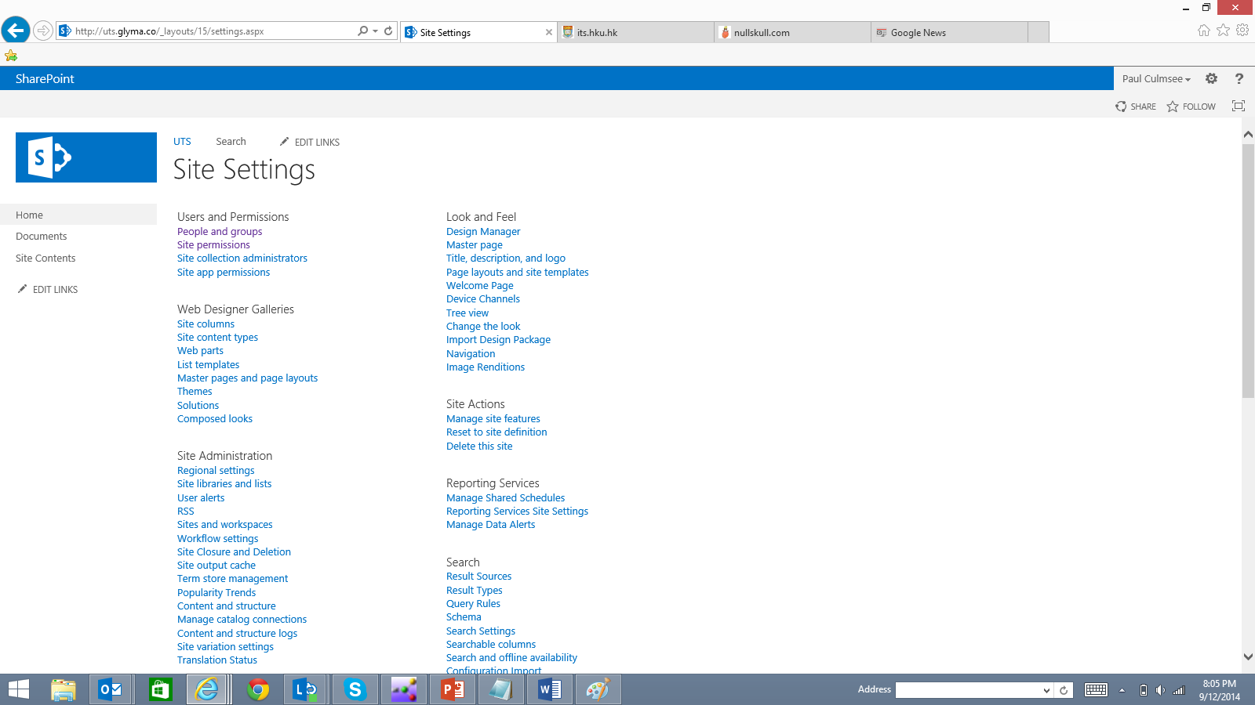

1. Choose the *Site Permissions* link from the *Users and Permissions* section. This will list all current SharePoint groups that have been added to the site. Click the *Create Groups* icon in the ribbon.

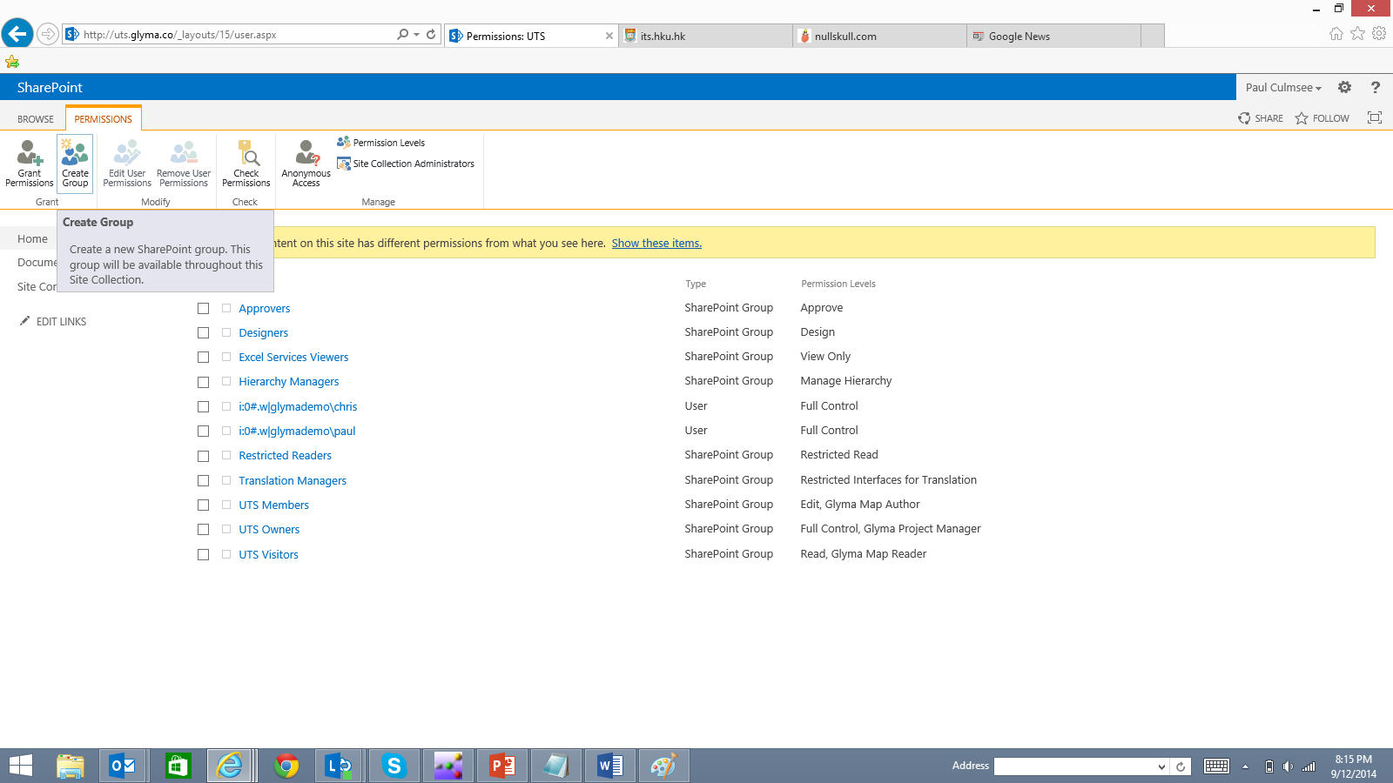

1. In the *Create Group* screen, enter a name for the group and accept all defaults. At the bottom of the screen, choose the Glyma Permission level desired. In the example below, we have created a group called “Department X” and assigned the *Glyma Map Managers* permission level.

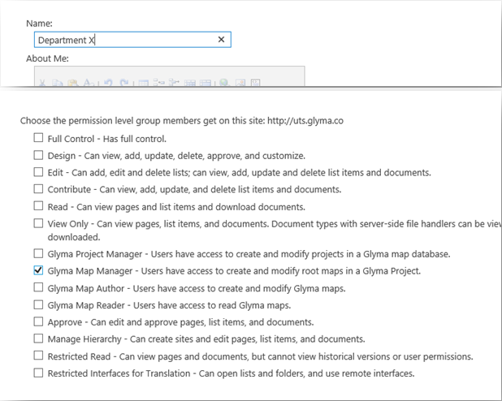

1. The new group has now been created.

*Note: These instructions do not cover all of the options for SharePoint group/permission management. Consult Microsoft documentation for more detailed guidance:* [*http://technet.microsoft.com/en-us/library/cc261972.aspx*](http://technet.microsoft.com/en-us/library/cc261972.aspx)

#### Assign the appropriate Glyma permission level to the groups in SharePoint

When your Glyma site is first provisioned, SharePoint creates some default groups. These are the Visitors, Members and Owners group. Often, it is sufficient to leverage these pre-existing groups and assign the following permission levels:

|  |  |
| --- | --- |
| Group | Permission Level |
| Owners | Glyma Project Managers |
| Members | Glyma Authors |
| Visitors | Glyma Readers |

These are performed via the following steps:

1. Navigate to the SharePoint site settings page (http://<yoursite.glyma.co/_layouts/settings.aspx). You will see the following admin screen.



1. Choose the *Site Permissions* link from the *Users and Permissions* section. This will list all current SharePoint groups that have been added to the site.
2. Find the owners group for the site and select it. From the ribbon, choose *Edit User Permissions*.

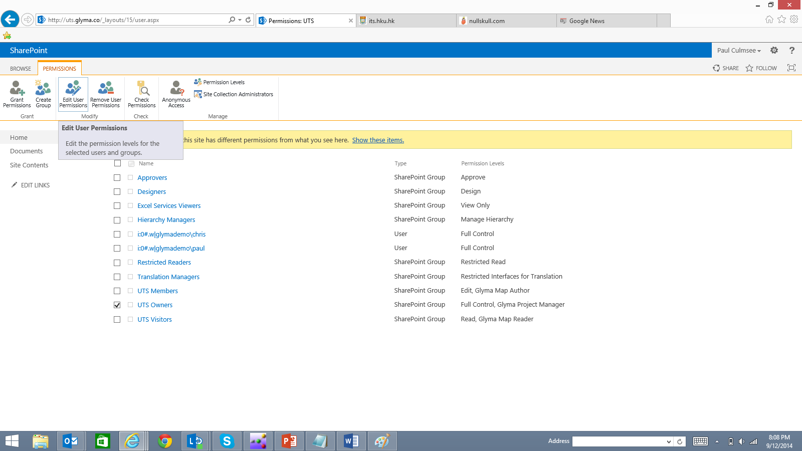

1. In the *Edit Permissions* screen, tick the *Glyma Project Managers* permission level and click *OK*.

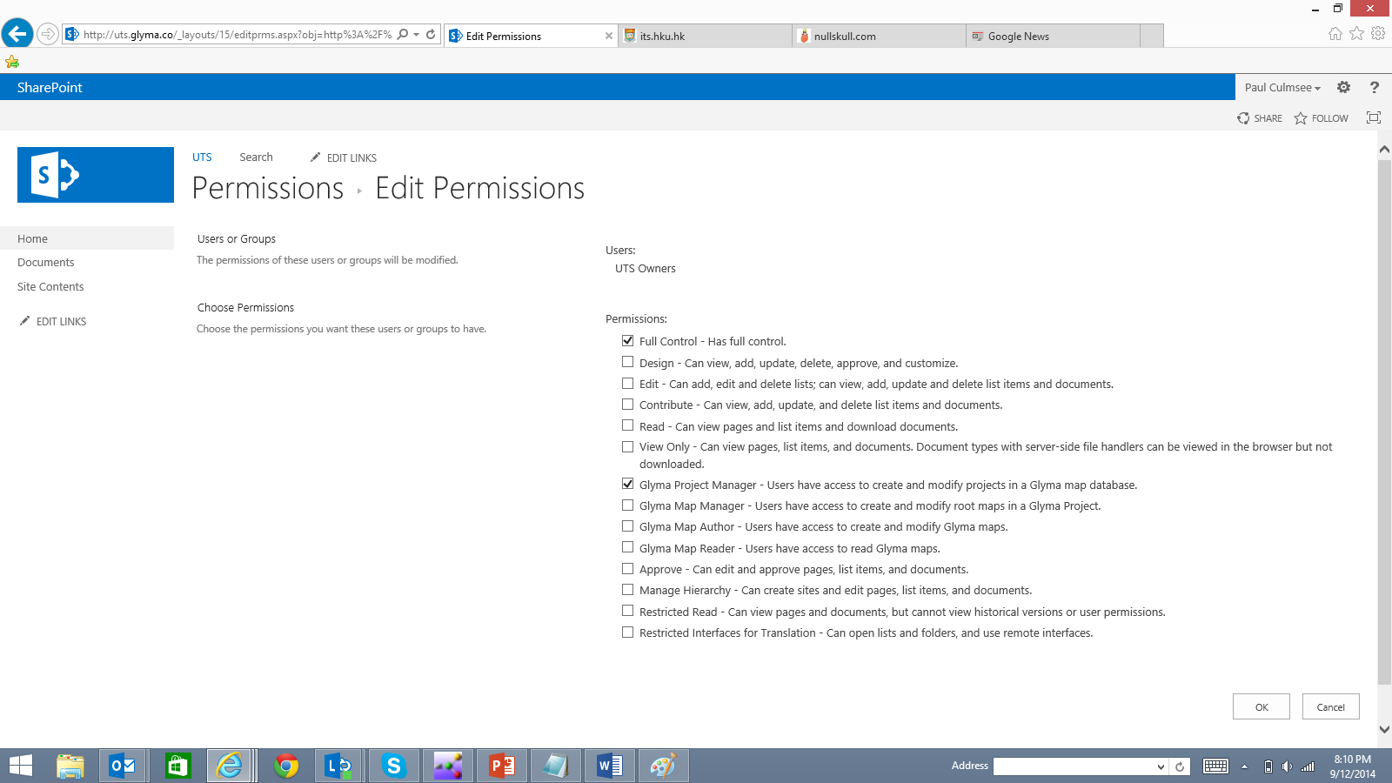

1. Repeat steps 1-4 for the Members and Visitors groups. Confirm site permission levels have been set as shown below:

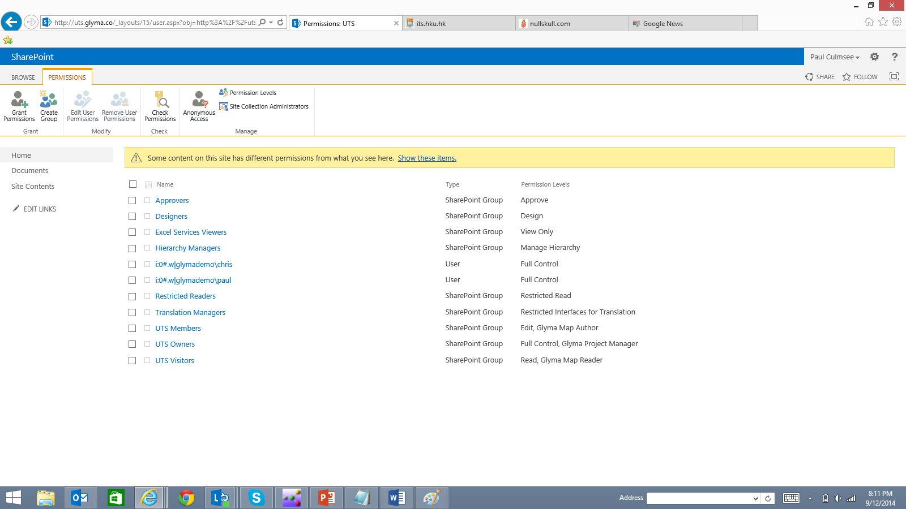

#### In Glyma management console, apply specific permissions to Glyma projects or maps

*Note: This section assumes that the account you are using to perform this task is a member of the Site Collection Administrators group.*

For many Glyma deployments, the default permission structure, as described in the previous section, is sufficient. However, if more fine grained permissions are required, follow the example below and change the group and permission level to suit your needs.

1. Add new SharePoint group and permission level using the process described earlier in this article. In this example we are assuming a group named *“Department X”* with the *Glyma Project Manager* permission level.



1. Open the *Glyma Management Console* and select a Glyma Project that you wish to assign the Department X access to.

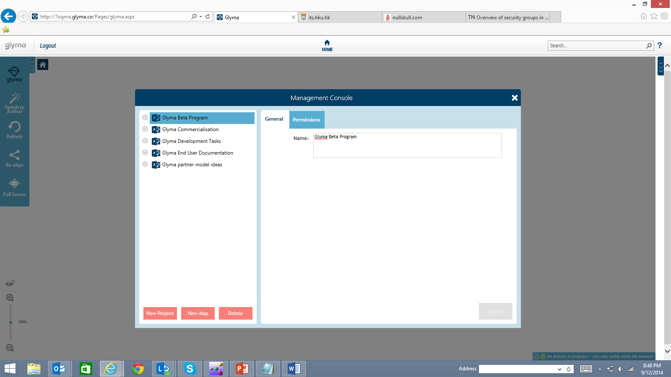

1. Click on the *Permissions* tab and choose the *Glyma Project Managers* permission level from the dropdown. Glyma will list the groups that have been assigned the Glyma Project Managers permission level. The newly created “Department X” group from step 1, will not be selected at this point.

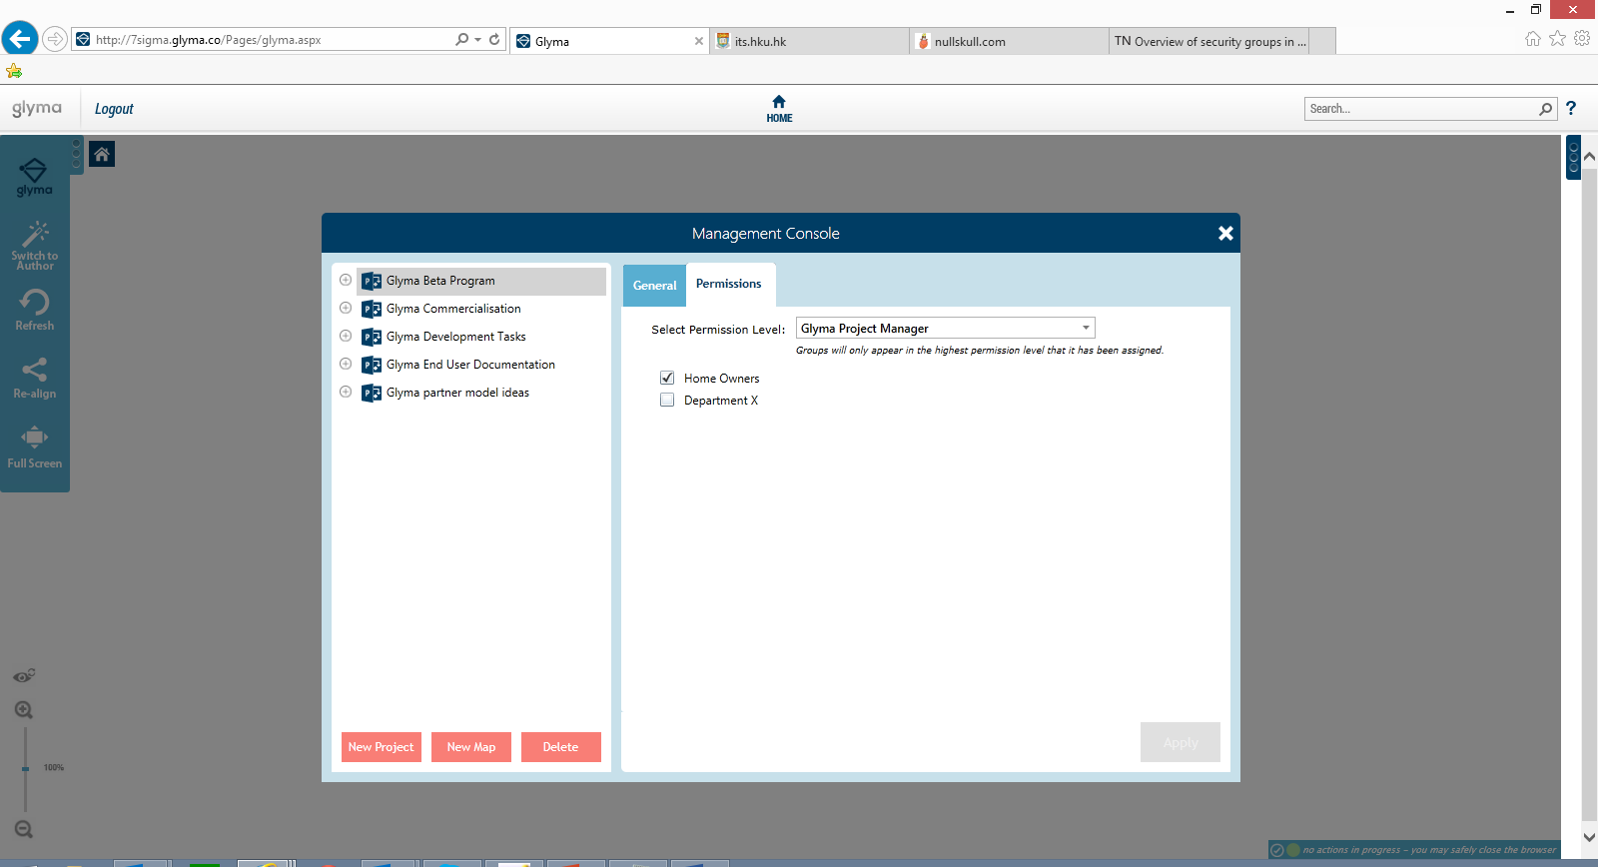

1. Uncheck the default Owners group and check the Department X group instead. Click *Apply*.

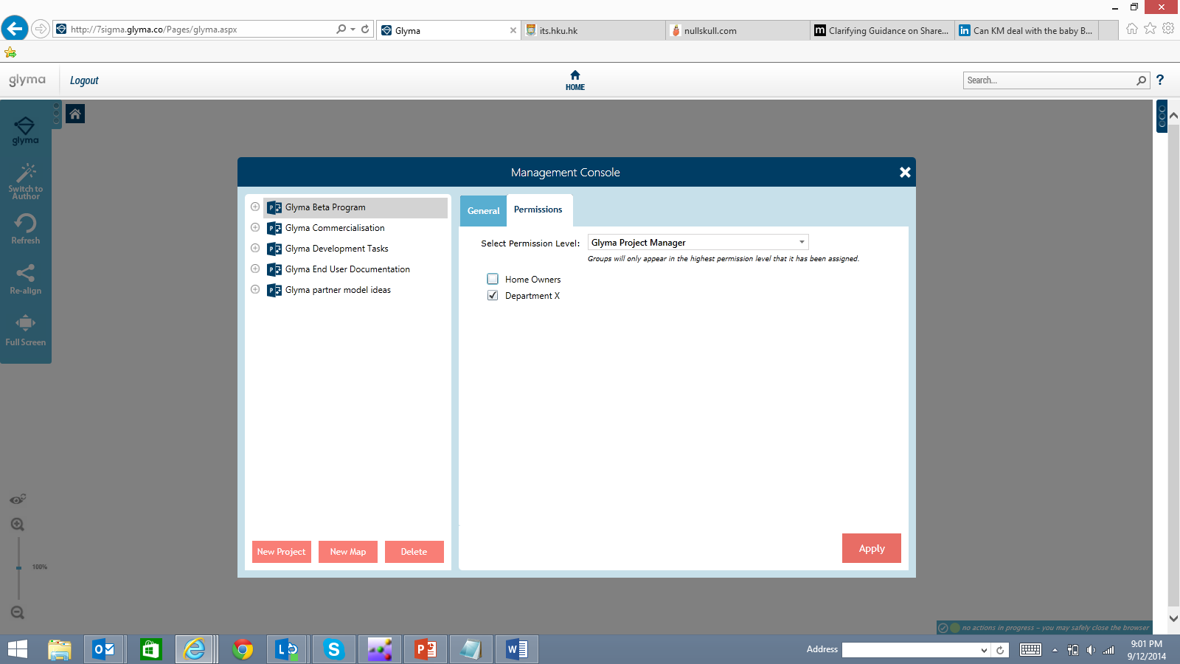

At this point, only members of the Department X have Glyma Project Manager permission to the selected Glyma project. The unchecked group will not be able to see this project in the list as shown below:

